**Project Description:**

**TTTAPP** is a simple Android application created by Gatal and Hao of Team UNRL with the idea of assisting users who often struggle to track their tap-to-pay transactions using multiple NFC wallet apps. The application’s main goal is to provide a clear and unified history of a user’s NFC wallet activity, helping them confirm if payments were successful and avoid confusion caused by checking different apps. TTTAPP is designed to help users stay informed and in control of their contactless payments. The intended users for the application are Android users especially college students and young adults who regularly use mobile wallets such as GCash, PayMaya, or Google Pay for daily purchases.

**Requirements Summary:**

|  |  |  |
| --- | --- | --- |
| **MINIMUM REQUIREMENTS** | Processor Cores | Single Core |
| OS | Android 4.4 (KitKat) |
| RAM | 2 GB |
| **RECOMMENDED REQUIREMENTS** | Processor Cores | Quad Core |
| OS | Android 8.0(Oreo) |
| RAM | 4 GB |
| **OTHER REQUIREMENTS** | Permissions | Notifications and Storage |

Table 1. System Requirements

To cater to low-end android models, the application will have at most a minimum of 1 Core, 2 GB worth or RAM, and Android version 4.4 or KitKat as its OS. The app itself is not at all demanding, hence our team has settled on lower requirement specs.

**Prototype Description:**

The Prototype was created with the use of Figma. This is because Figma is an interactive Prototyping Software/Website that can easily be distributed to testers with the use of links sent by the developers.

**TTTAPP Figma Link**:

<https://www.figma.com/proto/72xKCpHdxuxUTvpb6HO9sR/False-World-Concept-Designs?page-id=0%3A1&node-id=70-767&p=f&viewport=155%2C-1030%2C0.25&t=hiYwGHekrmQZydqu-1&scaling=min-zoom&content-scaling=fixed&starting-point-node-id=70%3A767&show-proto-sidebar=1>

**User Scenario:**

Scenario 1 - Shiro always forgets which E-wallet she used for a transaction. Because of this, she often forgets the monthly subscriptions of her content creation tools which caused her to lose access to the exclusive features.

Scenario 2 - Alex, who uses multiple online wallets, is on a shopping spree and keeps on using the tap-to-pay feature on his phone. At the end of the day Alex is unsure of which wallets were used in his shopping spree.

**TTTAPP Mock-up/Prototype**:

.

|  |  |
| --- | --- |
| **PROTOTYPE** | **DESCRIPTION** |
| Picture | This is the initial screen of the app when the user has not yet logged in. |
| Picture | This is the login screen where the user inputs their credentials and has options for signing up and recovering their accounts. |
| Picture | This is the register page where the user could create a new account by inputting their information. |
| Picture | This is a transition/loading screen which will be used for transitioning between screens. |
| Picture | This is the homepage where it displays quick informations about the user’s recent actions |
| Picture | This is the detailed transaction list where the user can view their transactions on a specific NFC wallet |
| Picture | This is the settings where users can tweak to their preference |
| Picture | This is the Profile tab where users can see their overall datas and also where users would connect their wallets. |

**Result Screen**

**Prototype Flow**:

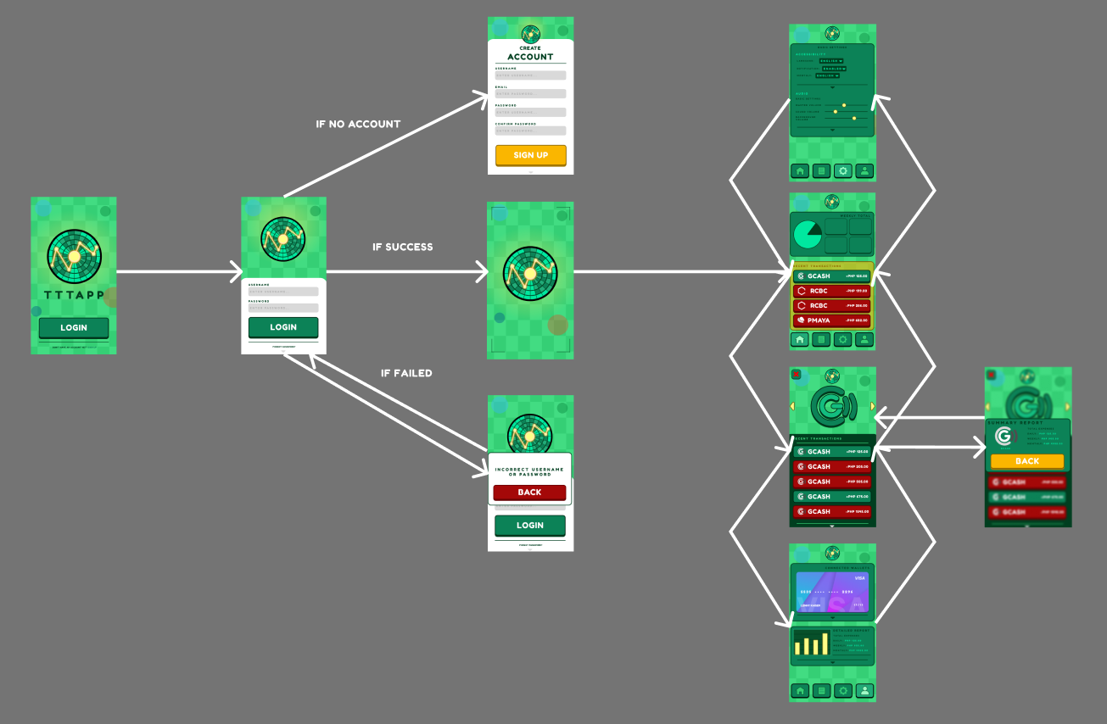

**Rationale:**

The team decided to use Figma to create the prototype because it is a free and interactive tool that both team members can use to edit the design together. It also helps the team easily show the final look of the app once it’s launched.

Figma is very useful for presenting and sharing the prototype with users who are not in the same place, and it’s easy to update the design when feedback is given.

However, Figma also has a few downsides. It needs an internet connection to save changes, so it won’t work properly if there’s no internet. Also, when using it on a larger screen, some buttons may look too small and hard to click, which could make editing a bit harder.

**Changes to the Requirements:**

There were no specific changes made to the system requirements, but there were some updates to the usability criteria for the prototype. These changes were made to help answer the question: “How easy is it for a user to use this prototype?”

The new criteria were based on some of the 10 Usability Heuristics, such as Minimalist Design, Recognition over Recall, Flexibility and Efficiency, User Freedom, and Consistency.

Also, we decided to remove the online features from the prototype because of limited time. Because of this, the criteria for online-related features were removed as well. The main goal now is to make the prototype as simple and easy to understand as possible so that users won’t get confused when using the full version later on.

**Initial Evaluation Plan:**

we used other ways like online platforms such as Microsoft Teams and Discord. This allowed us to still watch and follow what's happening with the prototype in real time.

Our evaluation plan is divided into three main parts: **Usability Specifications**, **Heuristics Evaluation**, and **Participant Survey and Feedback**.

**Usability Specifications**

The creation of this prototype will aim to achieve the following measures when it appeals to the use:

• **Effectiveness**: When accomplishing this measurement, it will show how well the prototype is at performing the required tasks.

• **Efficiency**: This measurement aims to show how easy and simple the prototype is used.

• **Utility**: This aims to show that the prototype will support suitable functions and alternatives to certain tasks

• **Learn Ability**: This will showcase how easy the users will learn to use the prototype system.

• **Memorization**: This will showcase how simple the users can remember steps when using the system.

**Population**

Around 5 to 10 selected **Android Users** will be asked to test the prototype. They will be given specific tasks to complete based on the features of the prototype.

**Prototype Tasks**

The tasks for this Prototype are split into three (3) different Sections: Main Menu, Profile Tab, and Transaction List Tab. Below are some of the tasks that the selected participants will be asked to perform for each Section to showcase the Prototype’s functionality:

• Enter and Exit the Prototype (**Main Menu Task**)

• How easy will the user be able to navigate while using the Prototype.

Reasons that these tasks were selected for the participants since the Prototype was designed with these measures in mind:

• Easy Navigation

• Allow users to do CRUD (Create Read Update Delete)

Roles

The team has will gather at the very least 10 participants when conducting this evaluation. With this is mind, team will split the population and have similar roles in this evaluation.

|  |  |
| --- | --- |
| **Developer / UI Designer Member** | **Task(s)** |
| Jan Alexander Gatal | Will be recording time users interact with a task section, taking notes of the user’s experience, and relay the task that the participant will do. |
| Lawrence I. Hao | Will be recording time users interact with a task section, taking notes of the user’s experience, and relay the task that the participant will do. |

Table 2. Team Member Tasks

|  |  |  |  |
| --- | --- | --- | --- |
| Main Menu | Within 1 minute or Below | Highly Acceptable | Successful |
| Above 1 minute | Not Acceptable | Unsuccessful |
| Login Screen | Within 5 minutes or Below | Highly Acceptable | Successful |
| Above 5 minutes | Not Acceptable | Unsuccessful |

Table 3. Time Interpretation

Table 3 represents the interpretation above represents how the team will be interpreting the time spent with each participant in their tasks. The table will be used as a guideline to interpret if the design of given task is successful or not at a given task.

**Heuristic Evaluation**

Evaluation of TTTAPPwill also use the 10 Usability Heuristic method of Evaluation.

Table 1: Evaluation Criteria (Based on the 10 heuristics of design evaluation) for website 1.

|  |  |  |  |  |  |
| --- | --- | --- | --- | --- | --- |
| **Area of Evaluation** | **5** | **4** | **3** | **2** | **1** |
| 1. **Visibility of System Status**  * - The system design provides appropriate feedback like message prompts in response to user actions. * The message prompts are clear, visible and understandable. | **✓** |  |  |  |  |
| **✓** |  |  |  |  |
| 1. **Match between the system and the real world**   - Used words, phrases and concepts according to users’ language rather than system oriented words and computer jargons. | **✓** |  |  |  |  |
| 1. **User control and freedom**   - The system design provides ways of allowing users to easily “get in” and “get out” if they find themselves in unfamiliar parts of the system. | **✓** |  |  |  |  |
| 1. **Consistency and Standards**  * - The colors, text, labels, buttons and other elements in the design are uniform from start to finish**.**   - Text and icons are not too small or too big.  **-** Menus and other features of the system are arranged and positioned in a consistent way. (For ex. If your website has navigation buttons on the top under the page title on one page, the users will automatically look there for the same features on other pages. | **✓** |  |  |  |  |
| **✓** |  |  |  |  |
| **✓** |  |  |  |  |
| 1. **Error Prevention**   - The system design provides an automatic detection of errors and preventing them to occur in the first place.  - Idiot proofing mechanisms are applied | **✓** |  |  |  |  |
| **✓** |  |  |  |  |
| **F. Help users recognize, diagnose and recover from errors**  **-** Error messages and the terms used are recognizable, familiar and understandable for the users. | **✓** |  |  |  |  |
| **G. Recognition rather than recall**  **-** Objects, icons, actions and options are visible for the user.  - Objects are labeled well with text and icons that can immediately be spotted by the user and matched with what they want to do. | **✓** |  |  |  |  |
| **H. Flexibility and efficiency of use**  - The system design provides easy to navigate menus.  - the system does not make wasteful time of system resources. | **✓** |  |  |  |  |
| 1. **Aesthetic and minimalist design**   **-**Graphics and animations used are not difficult to look at and does not clutter (mess) up the screen.  - Information provided is relevant and needed for the system design. | **✓** |  |  |  |  |
| 1. **Help and Documentation**   **-**the system design provides information that can be easily searched and provides help in a set of concrete steps that can easily be followed. | **✓** |  |  |  |  |

**Participant Survey and Feedback**

**After conducting the online test,**

|  |  |
| --- | --- |
| **DATA GATHERING METHOD** | **DESCRIPTION** |
| Survey (Quantitative) | After the Online Testing, the team will be handing out a survey to the participants to gather data for the user’s experience with the prototype which the team will be interpreting in a 5-point Likert scale (**Refer to Table 5**. **5-Point Likert Scale Interpretation**). |
| Feedback (Qualitative) | The survey that the team provided will support a Feedback section to help users/participants speak out concerns or issues with the prototype that needs to be addressed. |

Table 2. Data Gathering Methods

The table above showcases the three (3) different data gathering methods the team will be using while conducting the online test of the TTTAPP Prototype.

|  |  |
| --- | --- |
| **Question** | **Method of Answer** |
| **Section 1** | |
| Participant Number | Short Answer |
| On a scale of 1 to 5 how would you rate your experience with the TTTAPP Prototype | 5-Point Scale |
| On a scale of 1 to 5 how was the UI design of the prototype |
| How easily were you able to follow the tasks provided |
| **Section 2: Features of the Prototype** | |
| Login Screen | 5-Point Scale |
| Main Menu |
| Navigating the different tabs |
| Checking detailed summaries in profile |
| **Section 3: Feedback Section** | |
| Your Feedback | Short Answer |

Table 4. Survey Questionnaire

The table above presents the Questions that will be present in the survey for this Prototype. This survey will be handed to Participants after the Test using links.

**Task Time to Accomplish Tasks Interpretation Classification**

**Scale Range Value Interpretation Classification** 5 4.50-5.00 Highly Acceptable

Successful

4 3.50-4.49 Acceptable

3 2.50-3.49 Moderately Acceptable Neutral

2 1.50-2.49 Fairly Acceptable

Unsuccessful

1 1.00-1.49 Not Acceptable

Table 5. 5-Point Likert Scale Survey Interpretation

Table 5 represents the Interpretation of the survey questions given to the participants. The survey will be used as to interpret whether the design and features presented are successful and useful for android users who suffer from accounting issues.